Evolution of Students' Agency During a Complex, Collaborative Problem-Solving Assessment: An Eye-Tracking Study

Abstract

Understanding how students make decisions during complex problem-solving has typically relied on indirect measures. In this study, conducted using in-situ eye-tracking, we provide insight into agency as a distributed and power-laden process unfolding over time. Three collaborating engineering undergraduates wore eye-tracking sets during an in-class, complex assessment. By calibrating the three data streams, we defined moments of shared attention. Analysis of data streams by question, paired with activity-coded content logs, reveals differences in shared versus excluding agency. We first detected noticeable differences in status among the students by utilizing diagonal cross-recurrence profiles of the students' gaze data. Interestingly, one student led the learning process, despite not being the explicitly-named group leader, while the other two consistently followed his lead. We then found that we could predict instances of excluding agency with 77% accuracy using the Recurrence Rate and Trapping Time measures derived from a cross-recurrence quantification analysis of the gaze data coupled with a machine learning classification tree. This finding contributes to a more nuanced understanding of the applicability of cross-recurrence measures. Additionally, we found that the dynamics of excluding and shared agency evolved over time. The student with higher status frequently exhibited shared agency with the explicitly-named leader, but displayed excluding agency toward the group's third member. It seems that the behavior of the actual leader influenced the named leader to also display excluding agency towards the third member, who, as a result, became progressively disengaged and had his learning opportunities adversely affected. This study illustrates the relevance of eye-gaze behavior in understanding the complexities of collaborative learning dynamics when analyzed using appropriate methodologies.

Keywords: Collaboration, Learning Groups, Status, Agency, Excluding Agency, Joint Visual Attention, Decision-Making, Cross-Recurrence Quantification Analysis, Diagonal Cross-Recurrence Profile, Classification Tree, K-Fold Cross-Validation, Categorical Time Series, Machine Learning, Eye-Trackers

# 1. Introduction and research purpose

Understanding how to support students to collaboratively solve complex problems has been a major focus of research in the learning sciences, with most studies investigating the processes through analysis of video recordings and products and outcomes through both qualitative and quantitative methods. More recently, laboratory-based research studies have used eye-tracking methods to investigate how individuals approach and solve problems (Sharma et al., 2018); the increased availability of lower cost eye-tracking systems and advances in ways to integrate multiple data streams have made possible the study of collaborative problem-solving (Jermann et al., 2011); most such studies have occurred in laboratory settings (Ho et al., 2015).

We sought to explore the potential of mobile eye-tracking as a means to reveal how three collaborating students approached complex problem-solving *in-situ*. Specifically, we were curious about how they negotiated their agency across the problem-solving processes. Although individual and shared agency are well studied in other domains (e. g., Bratman, 2009; Bratman, 2013), agency remains undertheorized and inadequately operationalized in learning contexts. Most research on agency and its role in learning relies on self-report data or qualitative analysis of audio and video data (e. g., Damşa et al., 2010). Integrated gaze data of students may shed light on the role of agency in collaborative learning. The purpose of this study was to explore the potential of mobile eye-tracking as a means to reveal certain forms of agency—shared agency needed to address complex problem-solving, as well as its antipode, excluding agency—among three students during in-situ complex problem-solving. To guide our work, we posed the following research questions:

* Within a group of three students, how is power/status distributed, based on leading/following eye-gaze behavior?
* To what extent do cross-recurrence measures related to gaze predict excluding agency?
* How do the frequency, distribution, and associated behaviors of excluding agency change over time?

# 2. Review of the Literature

To guide our study, we first consider research on the role of agency in learning. We argue agency is critical in collaborative problem-solving as students negotiate their understandings together, and while managing status differences across learners. Within these reviews, we include research suggesting that gaze data provides more direct information about cognitive processes that are important during problem-solving (Konig et al., 2016; Rodrigues & Rosa, 2017), such as reading and typing (Rayner, 1998, 2009) and information processing (Desjarlais, 2017). We then review recent approaches to analyzing gaze data.

## 2.1. Agency and decision-making in learning

Classically, agency is defined in terms of intentionality, with humans planning actions with forethought, then monitoring and reflecting on their actions and consequences (Bandura, 2006). And rather than treating agency as free will, theorists have articulated a structure-agency dialectic, in which the choices a human can make are constrained by structures that are reproduced or impervious (Emirbayer & Mische, 1998; Giddens, 1984; Sewell Jr, 1992). Bringing this rational theory into the context of human action allows us to differentiate between accidental and intended actions.

Scholars extended agency to consider how it comes to be shared among collaborating or interacting humans. To be considered shared, those interacting should share both the decision and the belief that they are working in tandem, even if not working in duplicate (Bratman, 2009; Bratman, 2013). Related research on joint attention and its role in shared agency, using eye-tracking methods, likewise emphasizes that shared agency involves coordination between individuals, often in the form of gaze following (Caruana et al., 2017; Silver et al., 2021). The need to explicitly establish decisions and beliefs has been challenged by the observation that even not terribly coordinated young children somehow manage to act as if they have shared agency, in both behavior and outcome (Pacherie, 2013). Shared agency may therefore exist along a spectrum, from more durable shared agency that may be needed to complete highly complex projects, to emergent or fleeting shared agency needed to complete simpler tasks. Shared agency may be stabilized when formed through a collaborative narrative—that is, a jointly constructed and expressed, multi-step, structured intention, often accompanied by first-person plural pronouns (“we”) (Tollefsen & Gallagher, 2017). Without these attributes, individuals’ different values and intentions may form shallowly-shared agency.

However, these definitions of agency are inadequate for understanding the role of agency in learning and especially how it unfolds over time and is distributed across members of a group in a collaborative learning session. For instance, two individuals might explicitly share an intention to skip their class and spend their time relaxing. Unfortunately, agency remains comparatively undertheorized in the education research literature (Rajala et al., 2016), and is sometimes presented undefined in a list of related terms, like voice and ownership. While other constructs related to learning, like self-efficacy, have been situated (e.g., math self-efficacy, academic self-efficacy), agency is commonly undifferentiated. Yet the nature and consequentiality of decisions varies, and this variability matters for learning. Efforts to contextualize agency have primarily focused on epistemic agency—being responsible for knowledge advancement (Scardamalia, 2002). Research on epistemic agency offers insight into how it may be shared among learners collaborating over time, with both epistemic (e.g., recognizing uncertainty, gathering information, sharing information, generating ideas, using feedback) and regulative (e.g., setting and monitoring progress toward goals, managing collaboration) aspects (Damşa et al., 2010). A challenge with this approach is its breadth, as the varied activities within each aspect do not hold the same level of difficulty or consequentiality. We thus also draw inspiration from an approach that focuses on learner’s agency in framing design problems for its attention to consequentiality; framing agency is defined as making decisions that are consequential for what students learn by way of their having responsibility for framing the problems with which they engage (Svihla et al., 2021).

In the current study, we investigate how three learners, working on complex problems, display their agency as they work and learn in a group to gain insight into both epistemic and regulatory aspects of agency. The complexity of the tasks—highly technical, authentic engineering problems on an in-class, collaborative exam—should benefit from more than shallowly-shared agency.

## 2.2. Status and learning in collaborative settings

Studies of cooperative and collaborative learning sometimes differentiate between these (Davidson & Major, 2014). Cooperative learning is commonly treated as less consequential co-work of shorter duration, characterized by instructional approaches like think-pair-share and jigsaw. In contrast, collaborative learning emphasizes social meaning-making, with individuals working on epistemic tasks. Thus, the latter suits our aim of investigating how students share their agency over time, together, while working on complex problems.

Research suggests that certain features of interaction and discourse amongst members are key to collaborative learning, and some of these are readily detectable from eye movement data. Research comparing the behaviors of more and less successful groups highlights the importance of the discussion and uptake of correct ideas (Barron, 2003), which tend to emerge from inaccurate contributions that are correctly evaluated (Chiu, 2008). In simple problem-solving, successful students tend to focus their gaze on relevant elements, such as selected solutions, spending less time on those they consider incorrect (Tsai et al., 2012). Such linkages occur because eye movement patterns are mental activities that unveil and affect problem-solving as a cognitive process (Spivey & Dale, 2011). Moreover, there is evidence that the cognitive goals of the specific activity determine the eye movement behavior (Hayhoe & Ballard, 2005), like the increase in the number of fixations (gazes that last more than 200 ms at the same point) during the evaluation stage of a decision-making process, compared to a related search activity (Gidlöf et al., 2013).

Extending these insights to collaborative situations requires focus on both what individuals are doing and whether they appear to be attending to the same tasks. Joint attention and shared cognition are positively connected during effective collaborative problem-solving activities (Barron & Roschelle, 2009), where learning happens as a synergy based on common ground and effort (Schneider et al., 2018; Schwartz, 1995). In collaborative gaze studies, this is characterized by joint visual attention (JVA) (Schneider et al., 2018). Different rates of JVA during collaborative tasks are related to learning acquisition (Belenky et al., 2014) and to the level of success of pair collaboration (Villamor & Rodrigo, 2019). Differences in patterns of eye-movement behavior in paired, collaborative problem-solving tasks are also related to differences in prior knowledge, level of success, and the specific stage in the problem-solving process (Sharma et al., 2018).

Such interactions also involve both individual and shared agency as students negotiate to co-construct knowledge, integrate ideas shared by one another, and propose amendments to peers’ ideas (Mueller et al., 2012). However, the recognition that collaborative learning depends on exploring both accurate as well as inaccurate ideas (Chiu, 2008) raises two related issues for agency in collaborative learning: given that the varied ideas learners hold can be a resource, it may be important that they have shared agency in terms of aims and regulatory processes, but not in terms of epistemic agency, as too much overlap might prevent them from making progress. In turn, such differences are not always valued by learners, resulting in power and status differentials that can negatively impact learning. Agency tends to evolve over the course of collaborative learning activities (Haataja et al., 2022), and as a result, power and status intersect with this process over time. While learners’ social identities certainly play a role (e.g., implicit and explicit bias related to race, ethnicity, gender, etc.) (Wortham, 2004), even in apparently homogenous groups, status differences may emerge over time. Interpersonal disagreements can hinder collaborative learning, even as disagreements about the task can be productive (Lee et al., 2015). Instead of shared agency, learners may reject or exclude the ideas of their peers, or otherwise ignore their efforts to contribute. Drawing on recent work that defines excluding agency as interactional and linguistic moves that mitigate others’ participation (Dang-Anh, 2020), we consider excluding agency to be the antipode to shared agency.

Gaze data also provide insight into social interactions and status (Capozzi & Ristic, 2022; Ciardo et al., 2013; Dalmaso et al., 2012; Gobel et al., 2015). In social situations, people tend to look more often at those perceived having high status (Foulsham et al., 2010). Members not only look for the leader’s signals but also tend to follow their gaze (Gerpott et al., 2018; Gontar & Mulligan, 2016) and more generally, to follow the gaze of those considered to have a higher status (Dalmaso et al., 2020; Weisbuch et al., 2017). However, when *placed* in a leader role, an individual who does not demonstrate the necessary behaviors may fail to garner gaze following from other members (Capozzi et al., 2016; Dale et al., 2011). Studies like these provide empirical evidence that eye movement behavior can provide insight into situational and evolving status dynamics.

## 2.3. Eye-tracking data allow for analyzing eye movements using different approaches

Eye-tracking devices are widely used in research involving eye movement because eye-trackers allow for various measures of eye movements and visual attention (Hayhoe & Ballard, 2005) through the recording of the user’s eye(s) and the surroundings. Once the researchers determine the areas of interest (AOI), which are regions (features or objects) involved in the processes under study, eye-tracking detects specific locations at which the eye is looking (gaze points), the duration of the gaze within an AOI, gazes that last more than 200 milliseconds (fixations), and movements of the eye between two fixations (saccades). Gaze points and duration, fixations, and saccades are common measures provided by eye-tracking technology in educational research (Cook & Wei, 2017; Rodrigues & Rosa, 2017), which can be analyzed using a wide range of procedures. We describe these next.

### 2.3.1. Cross-recurrence quantification analysis (CRQA)

Eye-tracking data consists of time series of noisy and complex information. Cross-recurrence quantification analysis (CRQA) is an adequate approach to combine two time series originating from the eye movements of the members of a pair to study “interpersonal cognitive coordination” (Shockley & Riley, 2015, p. 413), the coordination of their joint attention (Richardson et al., 2007), and the quality of their interaction (Jermann et al., 2011), among others. CRQA plots and measures represent and quantify the similarity of two time series based on the repetition of elements or recurrence (Coco & Dale, 2014; Marwan & Kurths, 2002; Wallot & Leonardi, 2018b). For example, Figure 1 represents a recurrence plot and a cross-recurrence plot of sequences of letters that could represent coded AOIs, meaning that each letter corresponds to a different feature or object where a participant is looking at (reproduced from Wallot & Leonardi, 2018b). Figure 1A visualizes the recurrence of the same sequence of letters (same sequence on both axes), and Figure 1B visualizes the cross-recurrence of two different letter sequences; the black squares represent recurrence points because both associated letters (horizontal and vertical axes) are the same.

Multiple measures exist to quantify various characteristics of CRQA plots (Coco & Dale, 2014; Fusaroli et al., 2014; Marwan et al., 2007), which are helpful in understanding diverse aspects of group dynamics (Knight et al., 2016; Villamor & Rodrigo, 2018; Villamor & Rodrigo, 2022) and social interactions (Fusaroli et al., 2014). Percent Recurrence (RR) is one of the primary measures associated with cross-recurrence plots; RR describes the number of recurrent points in the recurrence plot, which is 28% in Figure 1A and 22% in 2A (number of black squares out of 100 total squares). Measures involving diagonals describe patterns of shared participant behaviors (gazes’ attunement) over time, such as Percent Determinism (DET), which computes the percentage of recurrence points that form diagonals; the higher the values of DET, the more attuned are the participants’ gazes. For example, Figure 1A presents a 71.4% determinism (20 black squares on diagonal lines out of 28 black squares), and Figure 1B presents a 63.6% determinism (14 squares aligned on diagonals out of 22 black squares). Other diagonal measures are Average Diagonal Line Length (L; 6.7 for 1A and 3.5 for 1B), Maximum Diagonal Line Length (maxL; 10 for 1A and 5 for 1B), Number of Recurrence Lines (NRLINE; 3 for 1A and 4 for 1B), and Shannon Entropy (ENTR). ENTR measures the complexity of the interaction between two individuals; the higher its value, the more complex the interaction, meaning that the lengths of the diagonals are irregular. High values of ENTR indicate that the gazes of the individuals in a dyad show inconsistent attunement. Lastly, the Renormalized Shannon Entropy (rENTR) is obtained by normalizing the ENTR measure by the number of diagonal lines in the recurrence plot; rENTR enables comparisons across diverse scenarios.

The cross-recurrence plot reveals two additional measures derived from its vertical lines. These measures provide valuable insights into the persistence and temporal dynamics of interactions between trajectories within the cross-recurrence plot. Laminarity (LAM) quantifies the proportion of recurrence points forming vertical lines above a specified length threshold, indicating the extent of repetitive behavior between trajectories. Trapping time (TT) represents the average duration that two trajectories remain in the same region, as indicated by the length of the vertical lines.

The limitation of CRQA to dyads is overcome by the application of Multidimensional Recurrence Quantification Analysis (MdRQA), a tool that allows for the recurrence analysis of more than two time series (Wallot & Leonardi, 2018a; Wallot et al., 2016). MdRQA also yields recurrence plots and similar quantification measures, although with the drawback of a less intuitive interpretation of the actual underlying phenomena and results obtained.

**Figure 1**

*Illustration of recurrence of letters in the sequence "ABCDABCD"* ***(A)****, and cross-recurrence of letters "ABCDABCD" with "DDEFGABCDD"* ***(B)***

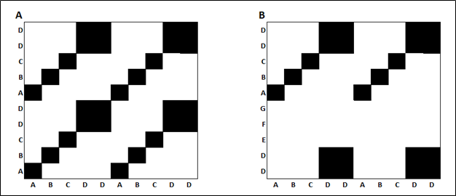

*Note*. The black squares in the matrices indicate the recurrence of a letter, and white spaces indicate the absence of recurrence. From “Analyzing multivariate dynamics using cross-recurrence quantification analysis (CRQA), diagonal-cross-recurrence profiles (DCRP), and multidimensional recurrence quantification analysis (MdRQA)–a tutorial in R,” by S. Wallot & G. Leonardi, 2018, Frontiers in psychology, 9, p. 3. Copyright by the authors. Reprinted with permission.

### 2.3.2. Diagonal cross-recurrence profiles (DCRP)

The main diagonal or Line of Synchrony (LoS) of a cross-recurrence plot corresponds to the values of the time series occurring at the same time. The study of the number of recurrence points on the main diagonal and in its surrounding area is called Diagonal Cross-Recurrence Profile (DCRP), which is useful for determining leader-follower behaviors (Dale et al., 2011; Richardson & Dale, 2005; Wallot & Leonardi, 2018b). A higher number of recurrence points on one side of the LoS within a narrow band along with it suggests the existence of leader-follower behavior because the gaze of the follower will visit the different AOIs with a certain lag after the visit of the leader (Fusaroli et al., 2014). Figure 2 shows a diagonal-wise cross-recurrence plot where the maximum value of recurrence (maxrec measure) occurs on the left of the LoS, line where the time lag is equal to zero, at a certain time lag (maxlag measure). If the maximum occurs on the left of the LoS, the participant represented on the horizontal axis of the corresponding recurrence plot would lead the interaction; if the maximum appears on the right, the leader would be the participant on the vertical axis of the recurrence plot.

**Figure 2**

*Diagonal cross-recurrence profile with a maximum on the left of the line of synchrony (lag = 0)*

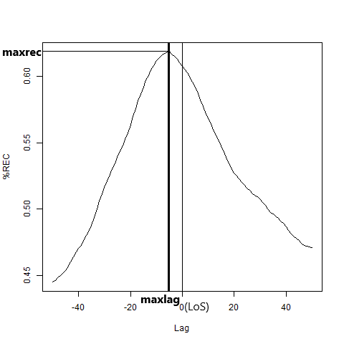

# 3. Methodology

## 3.1. Research design

We extended methods reported elsewhere for mobile eye-tracking of co-located dyads (Schneider et al., 2018) to triads. Below, we describe our in situ data collection approach and analysis strategies.

## 3.2. Participants & setting

We conducted the study in a required undergraduate engineering course on control theory at a research university in the southwestern US. The course enrolled 63 students, 16 from electrical and computer engineering, and 47 from mechanical engineering. Students participated in six in-class, scenario-based collaborative exams. Each exam included five questions, in roughly increasing order of complexity. Students worked in self-selected groups of three and chose which role (recorder, leader, monitor) to occupy.

We focused on the fifth exam that consisted of five questions. On this exam, the scenario involved an automatic focusing system in a charge-coupled device camera onboard the Mars Insight space mission. Solving the problems associated with the scenario required analysis via Nyquist and Bode methods. Students were provided with a transfer function model that described the dynamics of the lens positioning system. Students could apply tools for analysis of Nyquist diagrams and examine the relationship between Nyquist, Bode, and root locus diagrams. Specifically, students were asked to identify gain margin and phase margin in Nyquist diagrams, and challenged to relate these metrics to measures of stability via root locus and Bode diagrams.

## 3.3. Data collection and selection

For the data collection, we used three Pupil Labs eye-trackers ([www.pupil-labs.com](http://www.pupil-labs.com/)) that consisted of a headset with a front (world) camera, an eye camera, and a USB-C cable (Kassner et al., 2014). The headset is worn like a pair of glasses, and it is connected to a mobile device. After the required adjustments and calibration, the eye-tracker records a video of the eye of the user and a video of the different AOIs (world camera). We chose a group of three students who were willing to participate and did not wear glasses, which could hamper the correct adjustment and functioning of the eye-trackers. Each student in the group wore an eye-tracker for the duration of the exam.

To address the first and third research questions, we opted to analyze the data by dividing it into five sections, each corresponding to one of the five questions on the exam. The lengths of these sections enabled us to examine the power distribution among the members and observe the evolution of the excluding agency instances over time.

To address the second research question, we selected twenty 20-second segments distributed throughout the entire recording, characterized by either the presence or absence of excluding agency. We operationalized excluding agency as imbalances related to (a) decisions made authoritatively rather than via consensus; (b) an individual dominating the discussion; and (c) inequitable opportunities to contribute ideas. We coded each 20-second segment by dyad, attending to dyadic interactions rather than the actions of the third group member or prior interactions. For instance, if student A dismissed student B's opinion while considering student C's input, we coded this as an existing (Y) imbalance, manifested through excluding agency, between A and B, but not (N) between A and C. If student C also acknowledged student B's viewpoint, we coded the interaction as not exhibiting (N) excluding agency between B and C. We ensured a similar number of segments for each of the coding options. We chose segments with enough separation between them to avoid repeating the same excluding agency instance in two consecutive segments.

## 3.4 Data analysis

We processed each pair of coupled eye and world videos with an ad hoc application to compute gaze points, fixations, and saccades. The results of the video processing were augmented reality videos, where gaze points are represented as dots, fixations as rings, and saccades as lines within the front camera images. For the purpose of this study, we were interested in gaze points on different areas of interest (AOI) such as a computer, exam hardcopy, participants, calculators, and notebooks. The abundance of AOIs, the nature of some of them, such as the participants themselves, and the actual testing context of the natural setting under study prevented us from using fiducial markers to automate the collection and analysis of eye movements. Therefore we manually registered successive gaze positions (AOI) and their durations (tenths of second) from the processed video, using fixations and saccades as auxiliary measures to determine gaze points.

We synchronized the content logs and converted them into time series formed by the synchronized time in tenths of a second, and the AOIs coded as numbers for each participant. The rows of the time series correspond to consecutive tenths of seconds with no gaps in between from the beginning to the end of each video content log. The coding strategy was crucial for this study. Table 1 shows some of the codes we used for each of the three participants. We coded with the same number for each participant the AOIs directly involved in the collaboration process, such as a computer, the exam hardcopy, calculators, notebooks, the professor, and another group sharing the same table, to capture joint and shared attention. For example, we coded the computer as 1, the exam hardcopy as 2, and the professor as 11. Objects not involved in the problem-solving process, such as cell phones not used as calculators, walls, students at different tables in the classroom, and water bottles, among others, received a different code for each participant to avoid the false detection of joint attention. For example, a situation where the participants were checking their social media was not detected as joint attention because each cellphone received a different code.

**Table 1**

*Examples of codes assigned to the AOIs for each participant*

|  |  |  |  |
| --- | --- | --- | --- |
| AOI | Codes | | |
|  | Nathaniel | Steven | Jackson |
| Computer | 1 | 1 | 1 |
| Exam hardcopy | 2 | 2 | 2 |
| Participant | 3 | 3 | 3 |
| Nathaniel’s calculator | 6 | 6 | 6 |
| Nathaniel’s notebook | 7 | 7 | 7 |
| Steven’s calculator | 8 | 8 | 8 |
| Steven’s notebook | 9 | 9 | 9 |
| Professor | 11 | 11 | 11 |
| Another group at table | 13 | 13 | 13 |
| Object not involved | 10 | 18 | 19 |

Note: The names of the participants are pseudonyms.

We applied CRQA and DCRP to dyads of students (Nathaniel-Steven, Nathaniel-Jackson, and Jackson-Steven) using approaches available in the R package crqa (Coco & Dale, 2014) within an RStudio environment.

To address research question 1, we split the data into five parts corresponding to each exam question to compute the time series's diagonal cross-recurrence profiles (DCRP) later. The time the group needed to answer each question was long enough to study the power distribution among them based on similarities found in gaze behavior, such as joint (participants looking at the same AOI), shared (participants looking at each other), and recurrent (participants revisiting AOIs) gazes in a 100 ms band along the line of Synchrony (LoS). The LoS represents AOIs visited by both participants at the same time. We obtained 15 DCRPs, one per student dyad and exam question, representing the recurrence level at certain lags around the LoS for two participants. The presence of a maximum value of recurrence before or after the LoS could suggest a leader-follower relationship because one participant would tend to visit AOIs recently visited by the other participant. We also computed the maximum recurrence value (maxrec) and the corresponding time lag (maxlag).

To address research question 2, we analyzed twenty 20-second segments for each student dyad using cross-recurrence quantification analysis (CRQA), which would allow for extracting disaggregated behavior patterns. Each segment had the same starting and ending times for all three student dyads. A CRQA plot combines two time series to create a pattern of repetitions, where each square represents an AOI co-visited by both participants at the same or different times. The horizontal axis represents the time for the first student, in tenths of a second, and the vertical axis represents the time for the second student in the same units. In this case, the code assigned to each participant differed from the DCRP coding to better detect interaction nuances. The participants in a dyad received the same code to detect reciprocal eye contact; the third member received a different code. For example, the dyad members received the code 30 and the third member code 31. We also computed the quantification measures associated with each CRQA plot, such as RR, DET, L, maxL, NRLINE, ENTR, rENTR, LAM, and TT (Table 2).

**Table 2**

*Cross-recurrence measures utilized in this study*

|  |  |  |
| --- | --- | --- |
| Type of Analysis | Measure | Description |
| CRQA | RR | Percent Recurrence: Computes the ratio of recurrence points in the plot |
|  | DET | Percent Determinism: Computes the ratio of repetitions that are connected on diagonals |
|  | L | Average Diagonal Length |
|  | maxL | Maximum Diagonal Length |
|  | NRLINE | Number of Recurrence Lines: Computes the total number of diagonal lines |
|  | ENTR | Shannon Information Entropy of the diagonal lines |
|  | rENTR | Entropy normalized by the number of lines in the plot |
|  | LAM | Laminarity: Ratio of points forming vertical lines |
|  | TT | Trapping Time: Average length of vertical lines |
| DCRP | maxrec | Maximum Recurrence: Observed around the LoS |
|  | maxlag | Maximum Lag: Delay at maximum recurrence |

Note: CRQA stands for cross-recurrence quantification analysis and DCRP diagonal cross-recurrence profile.

We coded each twenty-second segment as Y or N based on the observation or absence of power imbalance manifested through excluding agency in decision-making processes.

We created a dataset for analysis formed by the binary coded “excluding agency” as the dependent variable and all the continuous crqa measures as independent variables. Among the different analytic options suitable for this dataset, we ruled out the application of a logistic regression because of the presence of multicollinearity among the independent variables and the fact that the observations were not independent (Demaris, 1995; Field et al., 2012; Harris, 2021). We also discarded using random forest or support vector machines because of the dataset's limited size. Consequently, we resolved to apply a machine learning classification tree approach, which can manage datasets without distribution requirements (Chen et al., 2011; Zumel & Mount, 2014), in conjunction with a k-fold cross-validation technique to test the accuracy of the results (Zumel & Mount, 2014) to avoid overfitting, which is a possibility when decision trees are applied on small datasets (Hämäläinen & Vinni, 2011). A decision tree is a supervised machine-learning algorithm that can be used for both classification and regression problems. It is a tree-structured classifier where internal nodes represent the predictors of the dataset, branches represent the decision rules, and each leaf node represents the outcome. Decision trees can handle both categorical and numerical data. K-fold cross-validation is a model evaluation technique that splits the available data into k subsets, with k usually between 5 and 10. The model then selects one of the k subsets and trains the model on the remaining k-1, using the selected k to test it. This process is repeated k times, so each subset is used as the test set once; the final evaluation metric is the average of the k results.

To address research question 3, we created two visualizations that enabled us to identify patterns in the temporal evolution of the collected data (Mazza, 2011). The first chart focused on the frequency and distribution of excluding agency instances throughout the succession of ordered segments; the second chart depicted the proportion of time spent by the group members focusing on different areas of interest (such as work tools, peers, and distractions), categorized by exam questions.

# 4. Results

We present results organized by research question.

## 4.1 Within a group of three students, how is power/status distributed, based on leading/following eye-gaze behavior?

As the fifth exam of the course, the students should have been familiar with the expectation of taking on roles of leader, recorder, and monitor. In this case, Nathaniel (names are pseudonyms) served as recorder, whose role was to keep an organized written record of the group's ideas and copy the answers onto the grading sheet; Steven as leader, whose role was to keep the group on task to complete allotted work; and Jackson as monitor, whose role was to monitor members' learning and inform the leader when the pace is too fast or slow, impairing the group learning.

The following results are based on the examination of the DCRPs for each dyad and question. On the first exam question, Nathaniel led Steven and Jackson with more than half a second lag (Figure 4 A and B). While Jackson seemed to lead Steven (Figure 4 C), the lag is small, meaning both could have followed Nathaniel at about the same time. On the second question, the only leader-follower relationship seems to exist between Nathaniel (leader) and Jackson (follower, seven tenths of second lag; Figure 4 E). Nathaniel and Steven present a strong and balanced simultaneous pattern, and there is no apparent leader-follower relationship between Steven and Jackson, presenting a weaker simultaneous pattern (two tips with a central depression; Figure 4 F). On the third exam question, Nathaniel again led Steven and Jackson (Figure 4 G; about half a second lag). Steven seems to lead Jackson, but the lag is very small; the meaning could be that both follow Nathaniel at about the same time. On the fourth question, the only leader-follower relationship can be found between Nathaniel (leader) and Jackson (follower, seven tenths of second lag; Figure 5 K). Finally, on the fifth question, the only leader-follower relationship can be found again between Nathaniel (leader) and Jackson (follower, half a second lag; Figure 5 N).

**Figure 4**

*Diagonal cross-recurrence profiles for exam questions 1, 2, and 3*

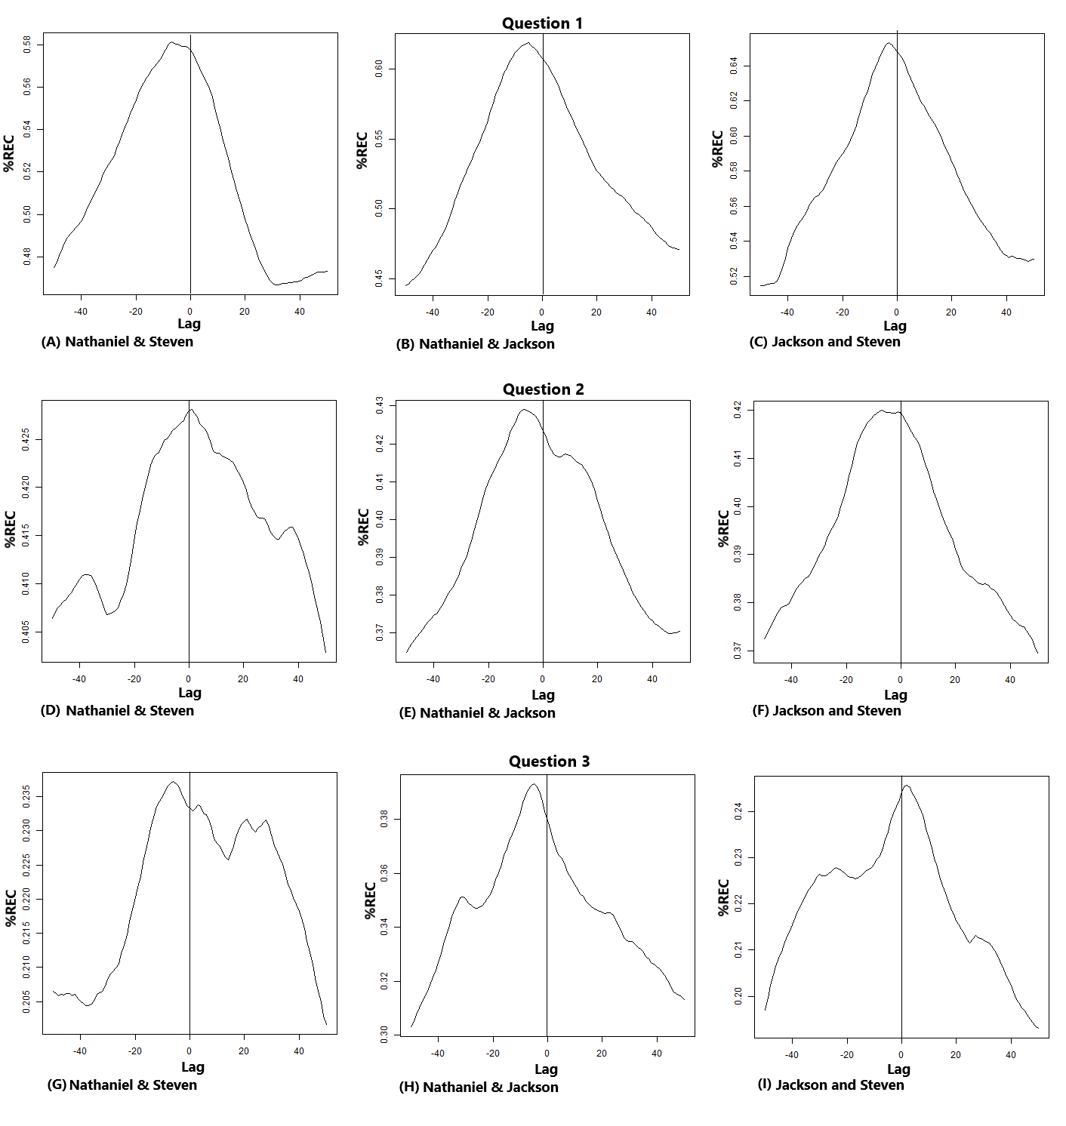

**Figure 5**

*Diagonal cross-recurrence profiles for exam questions 4 and 5*

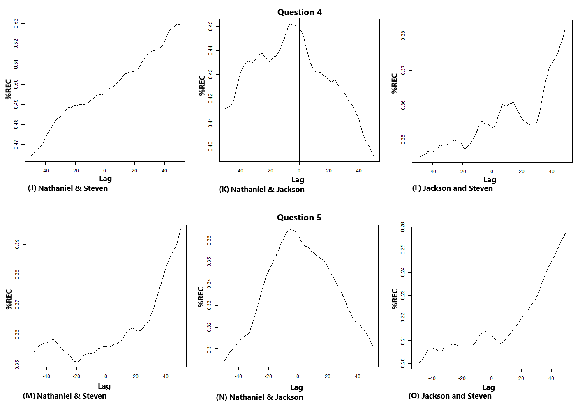

## 4.2 To what extent do cross-recurrence measures related to gaze predict excluding agency?

To answer this question, we first share vignettes highlighting excluding agency, as these formed the basis of the outcome of interest. Each vignette depicts three timepoints from each students’ point of view. The first vignette (Figure 6) occurred fifteen minutes into the group’s work together. In the first timepoint, all of the students’ gazes are directed to the same point on the computer screen, also indicated roughly by Steven’s finger as he asked for clarity about “the distance.” While Nathaniel engaged with this Steven’s question and corrected his misunderstanding, Jackson first made an audible “tss” sound that both drew attention and seemed to communicate a negative judgment about Steven’s question. He then leaned back in his chair, audibly making a “hmmmm” sound. His vocalization and movement attracted his group mates’ gazes, while he maintained his gaze on Nathaniel. Steven quickly shifted back to his aim of understanding his question, while Nathaniel encouraged him to ignore Jackson, gesturing his hand as if waving away Jackson, but quickly bringing his gaze back to the computer screen when Steven previously indicated “the distance.” In this vignette, we observe joint visual attention suggesting shared agency in terms of proximal aim—resolving Steven’s confusion—between Nathaniel and Steven, even as Nathaniel used his own agency to exclude Jackson. In this way, excluding agency served Nathaniel’s purpose of staying with that proximal, unresolved aim.

**Figure 6**

*First Example of a 20-Second Segment*

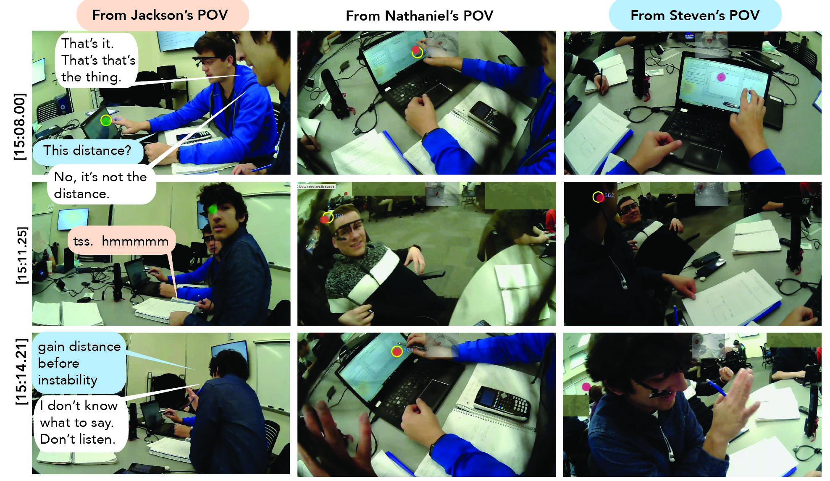

Note. An example of a 20-second segment from each students’ point of view; Nathaniel displays excluding agency toward Jackson in order to re-engage shared agency with Nathaniel.

The next vignette, approximately 10 minutes later, follows a moment of uncertainty in which the students arrived at a number that they were certain is incorrect, but were unsure how to proceed (Figure 7). In the first timepoint, Jackson offered a correction to one of the numbers Nathaniel had mentioned in his calculation, but Nathaniel initially ignored this, continuing his account of the process he’d followed. He misheard Jackson’s number and rejected Jackson’s contribution. During this time, both Nathaniel and Steven initially focused on their graphing calculators, working out the same problem. While Nathaniel’s gaze shifted briefly away from the calculator in rejecting Jackson’s contribution, it returned quickly to his own graphing calculator, where it remained in the second timepoint. Jackson restated his numbers while looking at Nathaniel. Meanwhile, Steven worked out a different process on his notebook, his gaze shifting from his notebook to his graphing calculator, before proposing it to his group. In the third timepoint, Nathaniel and Jackson shifted their gazes to Steven’s notebook, and Jackson challenged Steven, “Try it,” recognizing that although it was stated differently, it would result in the same answer. In this vignette, although Nathaniel and Steven did not share their gaze on the same object, they were similarly engaged with the same proximal aims, suggesting shared agency. Again, Nathaniel displayed excluding agency toward Jackson, perhaps falling into a pattern of doing so to maintain shared agency with Steven.

**Figure 7**

*Second Example of a 20-Second Segment*

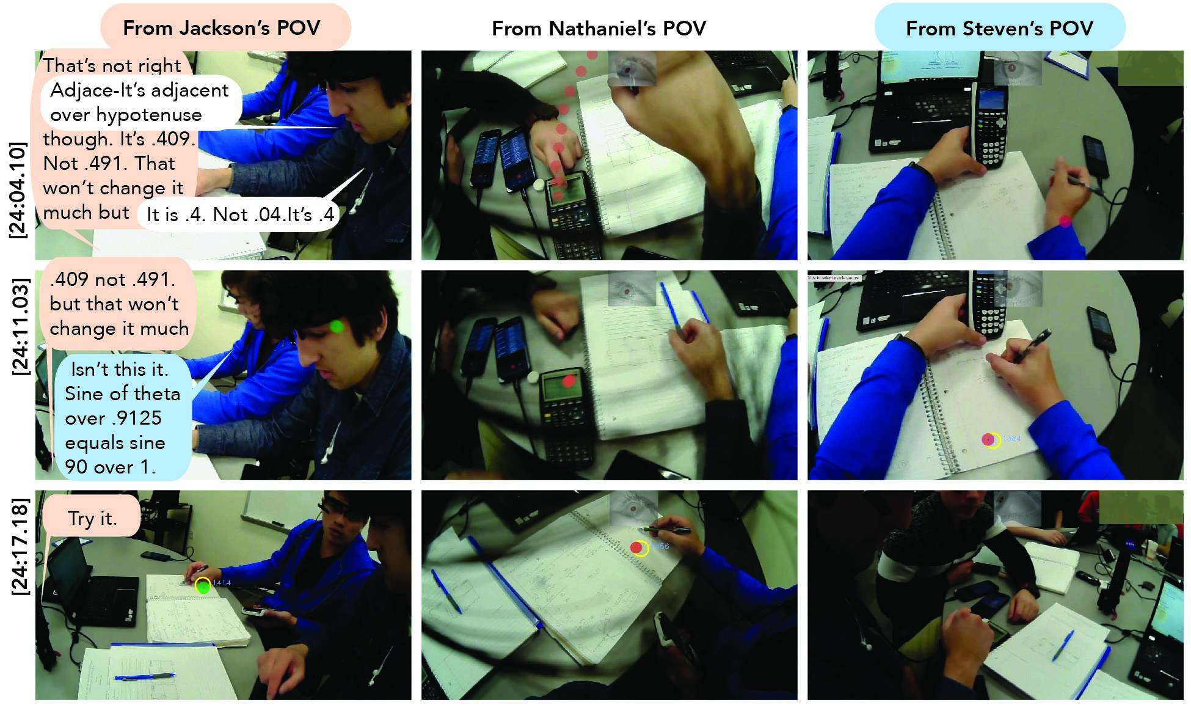

Note. Following a moment of uncertainty, Jackson offers a correction, initially ignored then misheard and rejected by Nathaniel. Steven suggests a different approach, and Jackson commands him to try it.

The third vignette, around 50 minutes into their work time, follows another moment of uncertainty (Figure 8). Having asked a question of the instructor, the group discussed what they each believed they needed to turn in, consulting with another group. In the first timepoint, Steven and Jackson discussed the problem, while Jackson made suggestions based on his interpretation of the instructor’s response. Across these three timepoints, Steven and Nathaniel held a separate conversation, overlapping with Jackson’s comments. During this, Steven maintained his gaze across his calculator and notebook, and Nathaniel maintained his gaze on the computer screen, suggesting similar proximal aims. In contrast, Jackson’s gaze jumped from Nathaniel’s face to Steven, finally coming to focus on his own hand as he tapped on an eraser. Prior to this vignette, although the students initially shared an explicit aim of resolving what their answer should include, differences in their perceptions may have again set up this pattern of Nathaniel and Steven sharing their agency around aligned proximal aims while displaying excluding agency toward Jackson .

**Figure 8**

*Third Example of a 20-Second Segment*

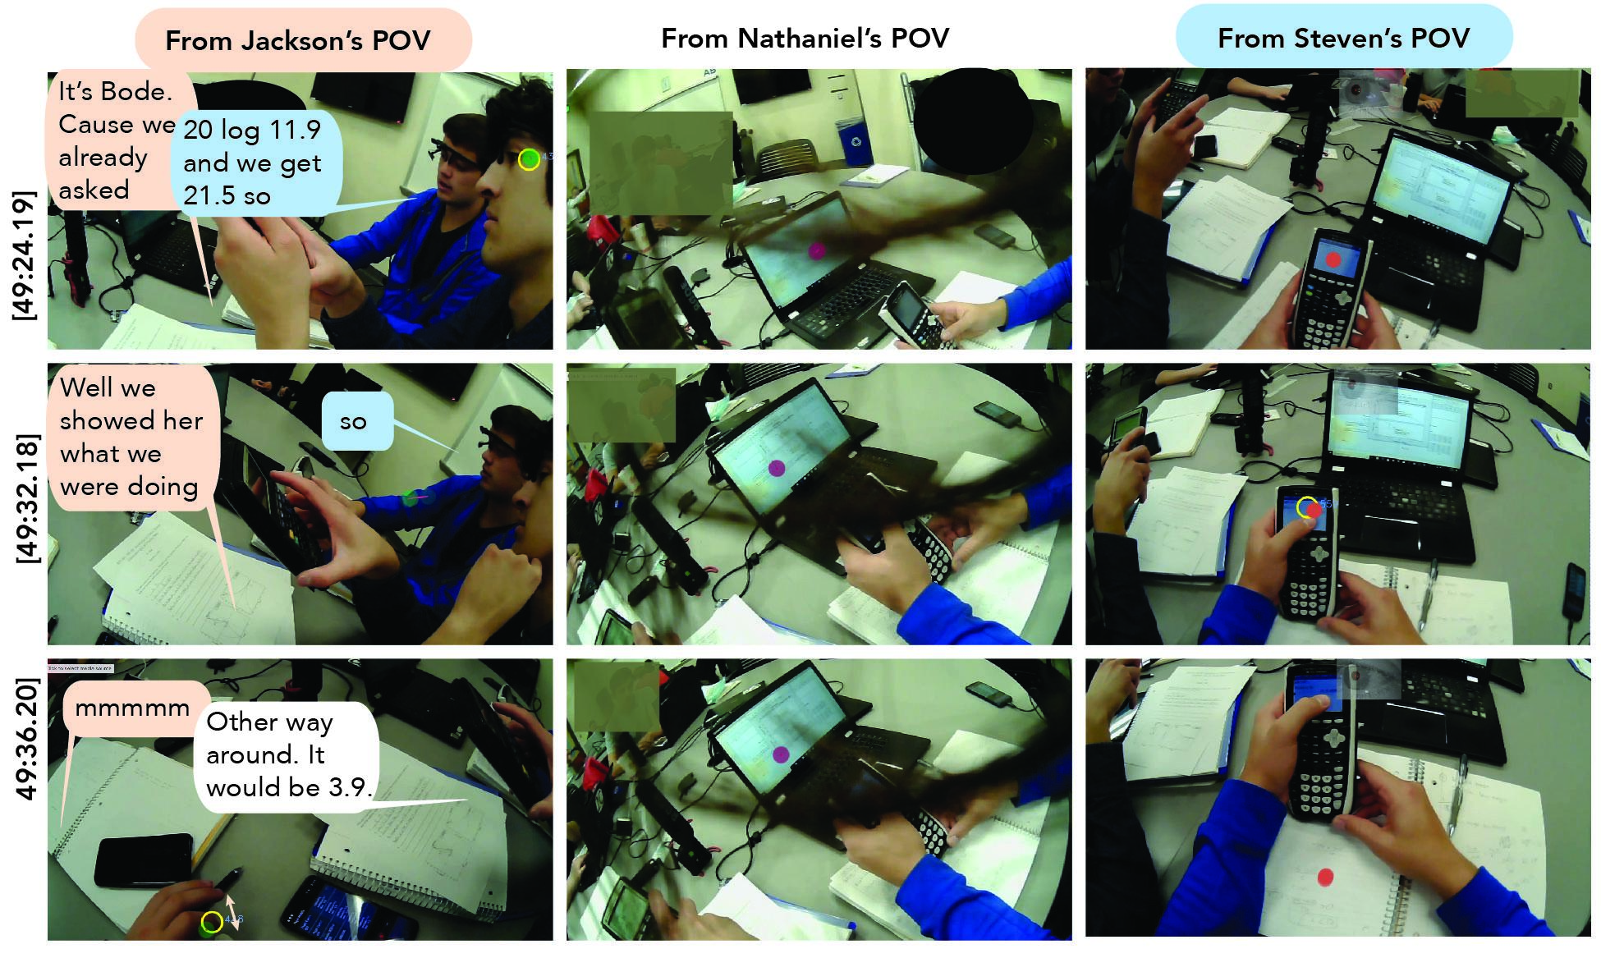

Note. Steven and Jackson discuss the problem, while Jackson makes suggestions, ignored by others, then fidgets.

We applied a cross-recurrence quantification analysis to each of the sixty 20-second segments, twenty per student dyad, obtained from the binary codification of the observation or absence of excluding agency in the augmented-reality videos from the eye-tracker recordings. We used the *crqa* R package in a Rstudio environment. The results from the analysis yielded a 60-observation (time segments) dataset containing nine crqa measures per row. Figure 9 displays the crqa measures corresponding to the first ten observations.

The next step involved applying the decision tree classification algorithm CART with k-fold cross-validation. We used a combination of the R packages *caret* and *rpart*, with the default set of parameters for the classification tree and k=10 with two repetitions for the cross-validation procedure.We included all the measures as predictors, and the classification algorithm selected RR and TT as the actual variables used in constructing the tree. Figure 10 shows the classification tree created by the machine learning algorithm, with TT and RR as splitting variables (nodes); the splitting values were TT=51.49 and RR=18.40. The tree classified an observation with TT >= 51.49 as Y, with TT < 51.49 and RR < 18.40 also as Y; an observation with TT < 51.49 and RR >= 18.40 was classified as N. The model achieved an average accuracy of 77% with a Cohen’s Kappa = 0.55.

**Figure 9**

*Measures Obtained from the Cross-Recurrence Quantification Analysis*

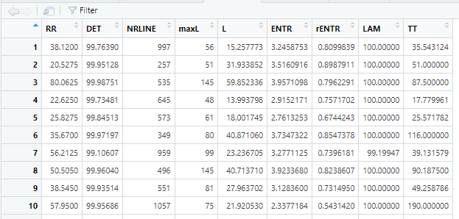

Note. Image from the RStudio screen corresponding to the first ten segments analyzed.

**Figure 10**

*Classification tree*

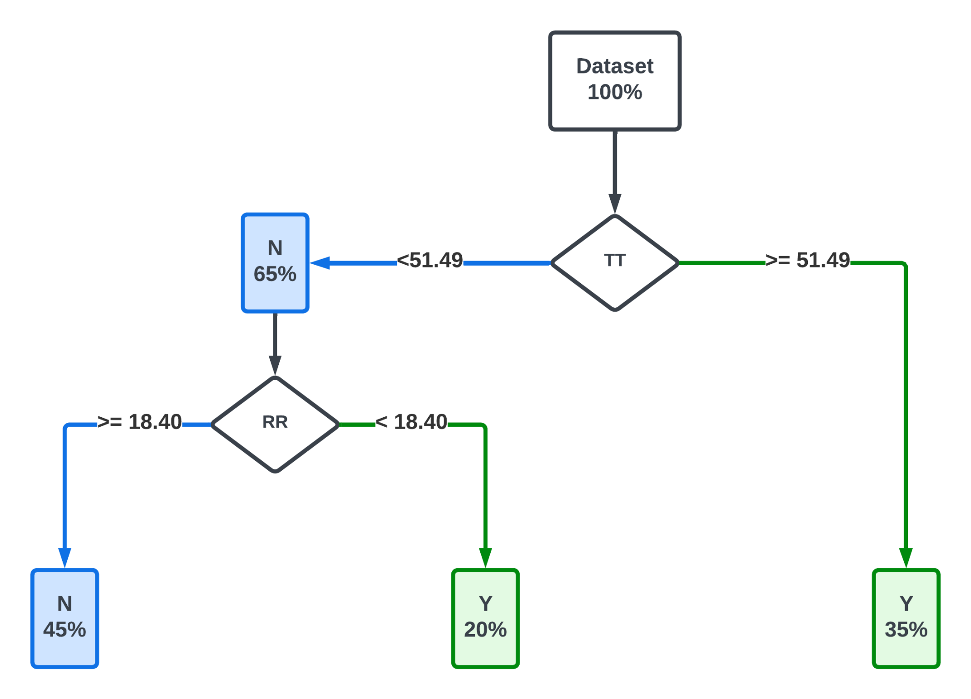

Note. The classification tree obtained has two nodes only, with Trapping Time (TT) and Recurrence Rate (RR) as actual measures used in its construction. The first node at the top of the tree classifies the observations as Y for TT greater than or equal to 51.49 (35% of total observations) and N for TT less than 51.49 (65% of total observations). The second node on the left side classifies the observations as Y for RR less than 18.40 (20% of total observations) and N for RR greater than or equal to 18.40 (45% of total observations).

## 4.3 How do the frequency, distribution, and associated behaviors of excluding agency change over time?

Figure 11 depicts the frequency and distribution of excluding agency instances throughout the succession of ordered segments. Of the sixty segments, 27 correspond to observed excluding agency instances, represented as green bars in the figure. The interactions between Nathaniel and Jackson were characterized by frequent instances of excluding agency, with Nathaniel acting as the exclusive agent. In contrast, the interactions between Nathaniel and Steven typically exhibited shared agency. Figure 11 also illustrates a shift in the interactions between Steven and Jackson, moving towards excluding agency in the second half of segments, with Steven emerging as the exclusive agent. Therefore, Jackson's role as the subject of excluding agency solidified over time, while the more balanced relationship between Nathaniel and Steven remained consistent.

**Figure 11**

*Observed Excluding Agency*

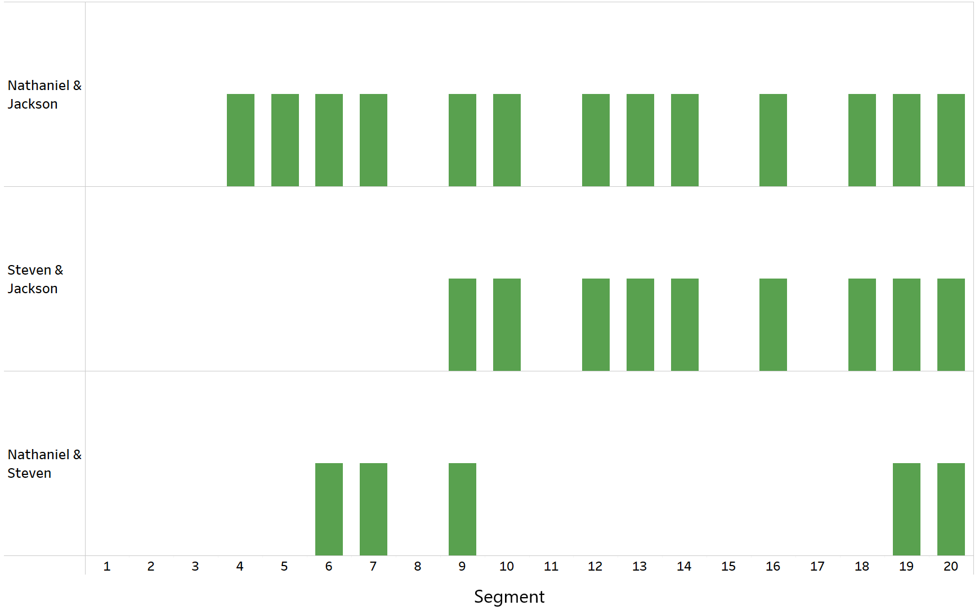

Note. Green bars represent segments where excluding agency was observed. The absence of a bar indicates segments where excluding agency was not observed.

Figure 12 depicts the percentage of time spent by the members focusing on different areas of interest as they move through the exam questions. Nathaniel and Steven consistently focused on work tools, such as the computer, the hard copy of the exam, calculators, and notebooks; the proportion of time they spent on distractions like cell phones and their surroundings was significantly less. Conversely, the proportion of time Jackson spent focusing on work tools decreased over time as his engagement with distractions increased. Regarding visual interactions among the members, Jackson and Steven were more adept at engaging with their peers visually, while Nathaniel did not engage in visual interactions as frequently.

**Figure 12**

*Proportion of Time in Each Exam Question Spent by Students Focusing on Different Areas of Interest*

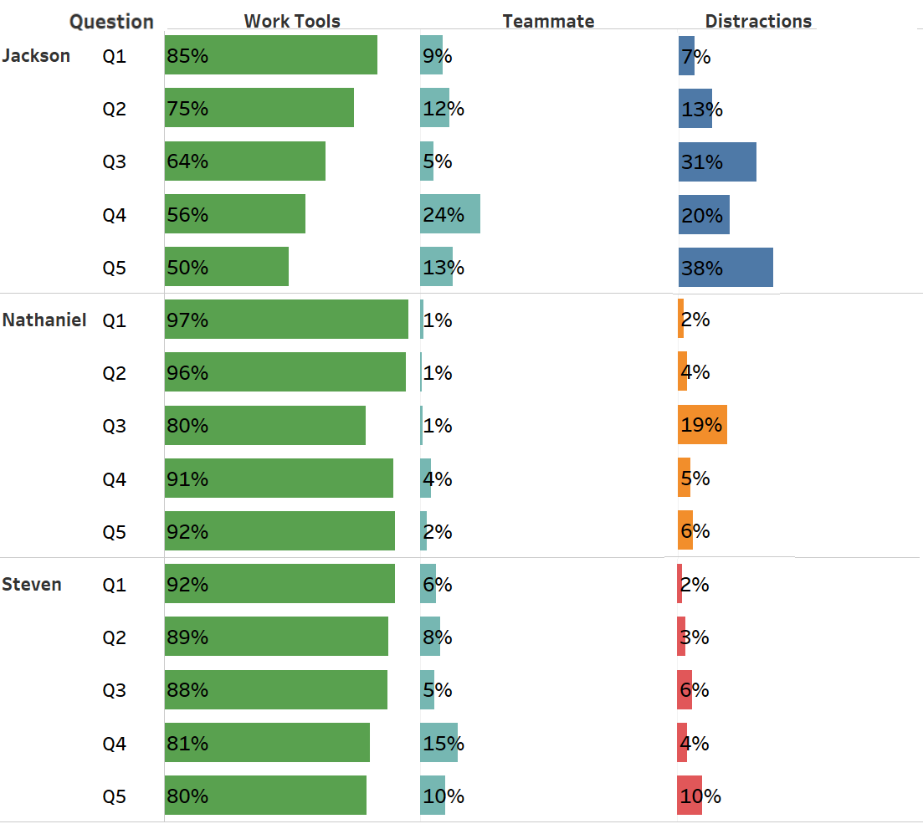

Note. Work tools refer to computer, exam hard copy, calculators, and notebooks.

# 5. Discussion

The findings from this study contribute to the understanding of agency, specifically *excluding agency,* and its evolution in collaborative learning dynamics in connection with members’ status through eye-gaze behavior measured using eye trackers. Empirical studies and theoretical papers support the use of various recurrence analysis approaches to study time series (Coco & Dale, 2014; Wallot & Leonardi, 2018) and specifically gaze data collected with eye-trackers (Dale, Kirkham, & Richardson, 2011; Jermann, Mullins, Nüssli, & Dillenbourg, 2011; Richardson, Dale, & Kirkham, 2007; Shockley & Riley, 2015). We applied diagonal cross-recurrence profiles (DCRP), cross-recurrence quantification analysis (CRQA), and machine learning algorithms to obtain and analyze cross-recurrence plots and measures that characterized the nature of the collaborative problem-solving interactions among the three participants in this study. We also created data visualizations to look for trends and patterns in the categorical time series developed in this study.

# Research studies have explored how leaders emerge in collaborative environments, usually using surveys/self-report data (Xie et al., 2014) or observing collaborative episodes and qualitatively coding behaviors (Carte, Chidambaram, & Becker, 2006; Li et al., 2007). We used eye-tracking to capture the status data and power distribution among the group members. We found that the DCRP plots were consistent across exam questions in identifying possible leader-follower relationships. This identification aligned with our direct observations of students’ behavior. We also observed that gaze data suggested the named/selected leader, Steven, was not actually leading. Instead, Nathaniel, in the role of recorder, led the collaborative problem-solving process. Perhaps Steven's conceptualization of leading was delegating—an effective strategy under some conditions. This suggests that, especially in short-duration problem-solving, selected leaders may not represent the actual members’ status, in turn underscoring the importance of using other means to evaluate the roles taken up by students in collaborative learning environments, as they can implicitly shape the dynamics of the group. We also note that given the time-consuming nature of qualitative analysis, gaze data can provide an indicator of where, in video data, to look for emergent leaders or power/status dynamics, making coding more manageable.

Our findings revealed that eye-gaze behavior can be a telling indicator of the power dynamics in collaborative settings. Specifically, the satisfactory outcomes of applying a decision tree classification algorithm suggested the predictive capacity of CRQA measures in identifying the presence of excluding agency in decision-making situations. The analysis showed that certain cross-recurrence measures, such as RR and TT, were instrumental in predicting the existence of excluding agency with an average accuracy of 77%. The results indicated that higher values of trapping time (TT >= 51.49), representing the average length of vertical lines, predicted instances of excluding agency. In this study's context, TT can be interpreted as a measure of the average time both members of a dyad were continuously focused on the same area of interest, although not necessarily at the same time. Lower values of TT, combined with low values of recurrence rate (RR < 18.40) or the percentage of recurrence points in the cross-recurrence plot, also predicted the existence of excluding agency. This suggests that instances of excluding agency can be characterized by low gaze coordination between dyad members. In contrast, the procedure predicted the absence of excluding agency instances for lower values of TT combined with higher values of RR, indicating higher levels of gaze coordination among members. Interestingly, none of the diagonal CRQA measures, which are related to members' attunement (Fusaroli et al., 2014), were determinant in the prediction model.

As noted in our literature review, shared agency exists along a spectrum—from shallow, fleeting joint attention to durable, explicit and jointly constructed intentional shared agency [cite Tollefsen & Gallagher, 2017]—and evolves over time [cite Haataja, 2022]. In our analysis of three students working together on complex problems, our analysis revealed that Nathaniel, the member with higher status, frequently exhibited excluding agency toward Jackson, while exhibiting shared agency with Steven, the explicitly-named leader, in that process. We consider ways this analysis sheds light on excluding agency [cite Dang-Anh, 2020] and shared epistemic agency—both as an epistemic and regulatory processes [cite Damsa, 2010], and the consequentiality for both epistemic and process-related aspects [cite Svihla 2021], especially given how Jackson, as the target of his peers' excluding agency, progressively disengaged from the collaboration process. Our work extends the construct of excluding agency as proposed by Dang-Anh (2020), characterized via exclusively linguistic methods. Our findings indicate that excluding agency is associated with detectable and characteristic eye movement behaviors in small learning groups, and our results suggest that it may have, as the antipode to shared agency, both epistemic and regulatory aspects, at least in the context of collaborative learning. First, in examining the segments of video coded as including imbalances, we can identify excluding agency in which Nathaniel or Steven directly ignore Jackson’s contribution—an epistemic process, as in Figures 7 and 8, as well as moments when Nathaniel and Steven regulate their work as shared while displaying excluding agency toward Jackson—a regulatory process, as in Figure 6. Although initially, Steven did not display excluding agency toward Jackson, over time, he also began to do so. Indeed, in alignment with research showing that members follow the gaze of leaders [cite Silver et al., 2021], it seems likely that Nathaniel’s behaviors influenced Steven in this regard, making them consequential for both the epistemic and regulatory aspects of the members’ opportunities for learning.

We also consider the roles that various artifacts and tasks, and different configurations of these, might have had on the status and agency displays. First, Steven, in the named-leader role and seated on the right, was the primary computer user and Nataniel, the leader-in-practice in the central seat, maintained ownership over the exam paper. Each student had a graphing calculator and notebook. We wonder if requiring the computer to be at the middle seat might have resulted in different dynamics over time, in part given Jackson’s decrease in gaze on work tools. Next, given research on shared agency suggesting that more durable sharing comes about as a result of jointly constructed and expressed, structured intention [cite Tollefsen & Gallagher, 2017], we posit that scaffolding students to make their plan explicit prior to working might support the development of shared agency. Such scaffolding could include individual work to identify what each student knows about the problem, followed by discussion of next steps to solve it, and might be incentived by being graded for the plan’s involvement of all members, rather than for its efficiency or accuracy.

# 6. Conclusions

In the first research question, we investigated power distribution in a collaborating group using leading/following eye-gaze behavior. We found consistent patterns in the analysis of eye-tracking data through DCRP that aligned with the direct observations of the student's status signals. The named leader was not actually leading, and the student in the role of recorder led the collaborative problem solving process.

In the second research question, we sought to determine the extent to which cross-recurrence measures associated with gaze predicted excluding agency. We applied CRQA and a decision tree classification algorithm to examine power dynamics based on eye-gaze behavior in a collaborative setting. We found that two specific CRQA measures, trapping time and recurrence rate, effectively predicted the presence of excluding agency instances in decision-making situations.

In the third research question, we sought to determine how the frequency and duration of excluding agency changed over time. We found that the interactions within the group were characterized by instances of excluding agency, primarily between the highest status member (Nathaniel) and another member (Jackson). Nathaniel frequently displayed excluding agency toward Jackson, sometimes in order to re-establish or maintain shared agency with the third member (Steven). Over time, Steven also started displaying excluding agency toward Jackson. Consequently, Jackson's role as the subject of excluding agency solidified while the more balanced relationship between Nathaniel and Steven remained relatively consistent. These findings suggest that Nathaniel, as the member with higher status, played a significant role in excluding Jackson from the collaboration process, leading to Jackson's progressive disengagement.

This study illustrates the relevance of eye-gaze behavior in understanding collaborative learning dynamics. We obtained valuable insights into power distribution and excluding agency within learning groups through advanced analytical methods, such as augmented reality video processing of eye-tracking data, DCRP, CRQA, and machine learning algorithms. These methodologies allowed for the detailed examination of those complex collaborative dynamics in a naturalistic setting.

## 6.1 Implications

We offer implications based on our results. First, the results emphasize that even when named and selected, leaders may not accurately reflect a learning group's actual status and dynamics. For those who study leadership in collaborative learning, it may be helpful to take a skeptical approach to self-reported information about who the leader is, or provide concrete descriptions of leadership behaviors and ask students to report who did each.

Second, our study highlights the potential for eye tracking methods. Gaze behavior can be an alternative or complementary source of data to self-reported data and video recordings of interactions in gaining insights into the complex power dynamics within even relatively homogenous collaborative learning groups. Methods to comprehensively explore the complexities of collaboration in educational settings should include the application of advanced analytical approaches, such as DCRP, CRQA, and machine learning algorithms, to gain insights from eye trackers and other multimodal data sources. Additionally, employing longitudinal designs can provide a valuable understanding of how the constructs under study evolve and their impact on group dynamics.

Third, educators who apply collaborative learning strategies should be mindful of the roles assigned to students and observe their interactions to identify emergent leaders, or offer scaffolds to assist students in noticing leadership behaviors. Addressing power dynamics and promoting inclusion is crucial, as higher-status members may exclude others from decision-making, which can be cumulatively consequential in constraining learning opportunties. As our findings reinforced the idea that agency evolves over time, instructors who notice early markers of excluding agency might intervene early, or offer tasks that better foster shared agency, offering a collaborative environment that fosters equity and engagement among all members. However, more research is needed to examine tasks and scaffolding that can support students to either develop shared agency or recognize when they are displaying excluding agency.

## 6.2 Limitations and future research

Our approach highlighted the feasibility of collecting eye-tracking data from three students during in situ collaborative problem-solving, and our analysis strategies shed light on member status and power imbalances in learning groups. However, it is important to recognize the limitations of this study. Firstly, the generalizability of our results may be limited because we collected data from only one group at a specific point in the semester when they had established productive working relationships. Secondly, the findings may not apply to ill-structured problem-solving scenarios since the exam problems examined were relatively well-structured. Additionally, the manual registration of gaze positions could have introduced potential errors and biases, affecting the accuracy of the collected data. Lastly, the small sample size used in this study restricts the generalizability of the findings, as the observed behaviors and interactions may be specific to the participants involved and may not represent a broader population. For instance, as we studied a group of three students, our results may not generalize to smaller or larger groups.

Future research should focus on several key areas to advance our understanding of collaborative dynamics. Firstly, the automation of eye-tracking data collection could greatly enhance the reliability and objectivity of the data obtained, although implementing it in naturalistic settings may present challenges. Secondly, it is crucial to explore the replicability of the results obtained in this study and investigate the influence of various contextual and instructional factors on collaborative processes. Furthermore, future studies should strive to incorporate larger and more diverse samples, including participants from various backgrounds and different collaborative settings, to improve the generalizability of findings. Future research can contribute to a more nuanced and comprehensive understanding of collaborative dynamics in educational contexts by addressing these areas. Finally, an important aspect that future research should cover is the detection of inequities among members based on internal and external status asymmetries, as this can provide additional insights into power dynamics within learning groups.

# Acknowledgments

This material is based upon work supported by the National Science Foundation under Grant No. [blind for review] and Grant No. [blind for review].

# References

Avolio, B. J., Kahai, S., & Dodge, G. E. (2000). E-leadership: Implications for theory, research, and practice. *The Leadership Quarterly,* 11(4), 615-668. doi:<http://dx.doi.org/10.1016/S1048-9843(00)00062-X>

Azevedo, R., Guthrie, J. T., & Seibert, D. (2004). The role of self-regulated learning in fostering students’ conceptual understanding of complex systems with hypermedia. *Journal of Educational Computing Research*, 30(1), 87-111. doi: <https://doi.org/10.2190/DVWX-GM1T-6THQ-5WC7>

Barron, B. & Roschelle, J. (2009). Shared cognition. In Anderman, E. (Ed.). *Psychology of Classroom Learning: An Encyclopedia*, pp. 819-823. Detroit, MI: Macmillan Reference USA.

Belenky, D., Ringenberg, M., Olsen, J., Aleven, V., & Rummel, N. (2014). Using Dual Eye-Tracking to Evaluate Students' Collaboration with an Intelligent Tutoring System for Elementary-Level Fractions. Paper presented at the 36th Annual Meeting of the Cognitive Science Society, Quebec City, Canada.

Capozzi, F., Becchio, C., Willemse, C., & Bayliss, A. P. (2016). Followers are not followed: Observed group interactions modulate subsequent social attention. *Journal of Experimental Psychology: General, 145*(5), 531. doi: <http://dx.doi.org/10.1037/xge0000167>

Carte, T. A., Chidambaram, L., & Becker, A. (2006). Emergent leadership in self-managed virtual teams. *Group Decision and Negotiation, 15*(4), 323-343. doi: <https://doi.org/10.1007/s10726-006-9045-7>

Chan, C. K. K. (2012). Co-regulation of learning in computer-supported collaborative learning environments: A discussion. *Metacognition and Learning*, 7(1), 63-73. doi: <https://doi.org/10.1007/s11409-012-9086-z>

Chiu, M. M. (2008). Flowing toward correct contributions during group problem solving: A statistical discourse analysis. *Journal of the Learning Sciences,* 17(3), 415-463. doi: <https://doi.org/10.1080/10508400802224830>

Coco, M. I., & Dale, R. (2014). Cross-recurrence quantification analysis of categorical and continuous time series: An R package. *Frontiers in psychology, 5,* 510. doi: <https://doi.org/10.3389/fpsyg.2014.00510>

Cook, A. E., & Wei, W. (2017). Using eye-movement to study reading processes: Methodologial considerations. In F. J. Was, F. J. Sansosti, & B. Morris (Eds.), *Eye-Tracking Technology Applications in Educational Research* (pp. 27-47). Hershey, PA: IGI Global.

Dale, R., Kirkham, N. Z., & Richardson, D. C. (2011). The dynamics of reference and shared visual attention. Frontiers in psychology, 2, 355. doi: <https://doi.org/10.3389/fpsyg.2011.00355>

Damiano, C., & Walther, D. B. (2019). Distinct roles of eye movements during memory encoding and retrieval. *Cognition, 184*, 119-129. doi: <https://doi.org/10.1016/j.cognition.2018.12.014>

Desjarlais, M. (2017). The use of eye-gaze to understand multimedia learning. In C. Was, F. J. Sansosti, & B. Morris (Eds.), *Eye-Tracking Technology Applications in Educational Research* (pp. 122-142). Hershey, PA: IGI Global.

DiDonato, N. (2013). Effective self- and co-regulation in collaborative learning groups: An analysis of how students regulate problem solving of authentic interdisciplinary tasks. *Instructional Science, 41*(1), 25-47. doi: <https://doi.org/10.1007/s11251-012-9206-9>

Foulsham, T., Cheng, J. T., Tracy, J. L., Henrich, J., & Kingstone, A. (2010). Gaze allocation in a dynamic situation: Effects of social status and speaking. *Cognition, 117*(3), 319-331. doi: <https://doi.org/10.1016/j.cognition.2010.09.003>

Fusaroli, R., Konvalinka, I., & Wallot, S. (2014). Analyzing social interactions: the promises and challenges of using cross recurrence quantification analysis. In *Translational recurrences* (pp. 137-155): Springer.

Gerpott, F. H., Lehmann-Willenbrock, N., Silvis, J. D., & Van Vugt, M. (2018). In the eye of the beholder? An eye-tracking experiment on emergent leadership in team interactions. *The Leadership Quarterly, 29*(4), 523-532. doi: <https://doi.org/10.1016/j.leaqua.2017.11.003>

Gidlöf, K., Wallin, A., Dewhurst, R., & Holmqvist, K. (2013). Using eye tracking to trace a cognitive process: Gaze behaviour during decision making in a natural environment. *Journal of Eye Movement Research, 6*(1), 1-14. doi: <https://doi.org/10.16910/jemr.6.1.3>

Gontar, P., & Mulligan, J. B. (2016). Cross recurrence analysis as a measure of pilots' coordination strategy. Paper presented at the 32nd European Association for Aviation Psychology (EAAP) Conference., Croningen, NL.

Greene, B. A. (2015). Measuring cognitive engagement with self-report scales: Reflections from over 20 years of research. *Educational Psychologist, 50*(1), 14-30. <http://dx.doi.org/10.1080/00461520.2014.989230>

Gressick, J., & Derry, S. (2010). Distributed leadership i<https://doi.org/10.10>n online groups. *International Journal of Computer-Supported Collaborative Learning*, 5(2), 211-236. doi: <https://doi.org/10.1007/s11412-010-9086-4>

Hadwin, A., Järvelä, S., & Miller, M. (2018). Self-regulation, co-regulation, and shared regulation in collaborative learning environments. *Handbook of self-regulation of learning and performance*, 2nd ed. (pp. 83-106). New York, NY, US: Routledge/Taylor & Francis Group.

Hannah, S. T., Avolio, B. J., Luthans, F., & Harms, P. D. (2008). Leadership efficacy: Review and future directions. *The Leadership Quarterly,* 19(6), 669-692. doi: <http://dx.doi.org/10.1016/j.leaqua.2008.09.007>

Hayhoe, M., & Ballard, D. (2005). Eye movements in natural behavior. *Trends Cogn Sci, 9*(4), 188-194. doi: <https://doi.org/10.1016/j.tics.2005.02.009>

Ho, S., Foulsham, T., & Kingstone, A. (2015). Speaking and listening with the eyes: gaze signaling during dyadic interactions. *Plos One, 10*(8). doi: <https://doi.org/10.1371/journal.pone.0136905>

James, A. M. (2009). Self-leadership and self-regulated learning: An investigation of theoretical relationships. *Journal of Business & Leadership: Research, Practice, and Teaching (2005-2012), 5*(1), 59-67. Retrieved from https://scholars.fhsu.edu/jbl/vol5/iss1/8

Järvelä, S., Järvenoja, H., Malmberg, J., & Hadwin, A. F. (2013). Exploring socially shared regulation in the context of collaboration. *Journal of Cognitive Education & Psychology,* 12(3), 267-286. doi: <https://doi.org/10.1891/1945-8959.12.3.267>

Järvelä, S., Järvenoja, H., & Veermans, M. (2008). Understanding the dynamics of motivation in socially shared learning. *International Journal of Educational Research*, 47(2), 122-135. doi: <https://doi.org/10.1016/j.ijer.2007.11.012>

Jermann, P., Mullins, D., Nüssli, M.-A., & Dillenbourg, P. (2011). Collaborative gaze footprints: Correlates of interaction quality. Paper presented at the CSCL 2011, Hong Kong.

Kassner, M., Patera, W., & Bulling, A. (2014, 09/13/2014). Pupil: an open source platform for pervasive eye tracking and mobile gaze-based interaction. Paper presented at the Proceedings of the 2014 ACM International Joint Conference on Pervasive and Ubiquitous Computing: Adjunct Publication.

Kim, D., & Lim, C. (2018). Promoting socially shared metacognitive regulation in collaborative project-based learning: A framework for the design of structured guidance. *Teaching in Higher Education*, 23(2), 194-211. doi: <https://doi.org/10.1080/13562517.2017.1379484>

Konig, P., Wilming, N., Kietzmann, T. C., Ossandon, J. P., Onat, S., Ehinger, B. V., . . . Kaspar, K. (2016). Eye movements as a window to cognitive processes. *Journal of Eye Movement Research, 9*(5), 1-16. doi: <https://doi.org/10.16910/jemr.9.5.3>

Law, V., Ge, X., & Eseryel, D. (2016). The development of a self-regulation in a collaborative context scale. *Technology, Knowledge and Learning*, 1-11. doi: <https://doi.org/10.1007/s10758-016-9274-z>

Li, Y., Anderson, R. C., Kim, N.-J., Dong, T., Anthi, A., Kim, I.-H., . . . Miller, B. (2007). Emergent leadership in children's discussion groups. *Cognition & Instruction*, 25(1), 75-111. doi: <https://doi.org/10.1080/07370000709336703>

Malmberg, J., Järvelä, S., & Järvenoja, H. (2017). Capturing temporal and sequential patterns of self-, co-, and socially shared regulation in the context of collaborative learning. *Contemporary Educational Psychology*, 49, 160-174. doi: <http://dx.doi.org/10.1016/j.cedpsych.2017.01.009>

Marwan, N., & Kurths, J. (2002). Nonlinear analysis of bivariate data with cross recurrence plots. *Physics letters A, 302*(5-6), 299-307. Retrieved from https://arxiv.org/pdf/physics/0201061.pdf

Rayner, K. (1998). Eye movements in reading and information processing: 20 years of research. *Psychological Bulletin, 124*(3), 372.

Rayner, K. (2009). Eye movements and attention in reading, scene perception, and visual search. *The quarterly journal of experimental psychology, 62*(8), 1457-1506. doi: <https://doi.org/10.1080/17470210902816461>

Richardson, D. C., & Dale, R. (2005). Looking to understand: The coupling between speakers' and listeners' eye movements and its relationship to discourse comprehension. *Cognitive Science, 29*(6), 1045-1060. doi: <https://doi.org/10.1207/s15516709cog0000_29>

Richardson, D. C., Dale, R., & Kirkham, N. Z. (2007). The art of conversation is coordination. *Psychological Science, 18*(5), 407-413. doi: [https://doi.org/10.1111/j.1467-9280.2007.01914.x](https://doi.org/10.1111%2Fj.1467-9280.2007.01914.x)

Rodrigues, P., & Rosa, P. J. (2017). Eye-tracking as a research methodology in educational contexts. In C. Was, F. J. Sansosti, & B. Morris (Eds.), *Eye-Tracking Technology Applications in Educational Research* (pp. 1-26). Hershey, PA: IGI Global.

Schneider, B., Sharma, K., Cuendet, S., Zufferey, G., Dillenbourg, P., & Pea, R. (2018). Leveraging mobile eye-trackers to capture joint visual attention in co-located collaborative learning groups. *International Journal of Computer-Supported Collaborative Learning, 13*, 241-261. doi: <https://doi.org/10.1007/s11412-018-9281-2>

Schwartz, D. L. (1995). The emergence of abstract representations in dyad problem solving. *The Journal of the Learning Sciences, 4*(3), 321-354. Retrieved from https://web.stanford.edu/~danls/Dyad%20Abstraction.pdf

Sharma, K., Olsen, J. K., Aleven, V., & Rummel, N. (2018, September 3-5). Exploring Causality Within Collaborative Problem Solving Using Eye-Tracking. Paper presented at the 13th European Conference on Technology-Enhanced Learning, Leeds, UK.

Shockley, K., & Riley, M. A. (2015). Interpersonal couplings in human interactions. In C. L. Webber & N. Marwan (Eds.), *Recurrence Quantification Analysis* (pp. 399-421): Springer.

Spivey, M. J., & Dale, R. (2011). Eye movements both reveal and influence problem solving. In S. Liversedge, I. Gilchrist, & S. Everling (Eds.), *The Oxford handbook of eye movements* (pp. 551-562): Oxford University Press.

Trevors, G., Feyzi-Behnagh, R., Azevedo, R., & Bouchet, F. (2016). Self-regulated learning processes vary as a function of epistemic beliefs and contexts: Mixed method evidence from eye tracking and concurrent and retrospective reports. *Learning and Instruction*, 42, 31-46. doi: <https://doi.org/10.1016/j.learninstruc.2015.11.003>

Tsai, M.-J., Hou, H.-T., Lai, M.-L., Liu, W.-Y., & Yang, F.-Y. (2012). Visual attention for solving multiple-choice science problem: An eye-tracking analysis. *Computers & Education, 58*(1), 375-385. doi: <https://doi.org/10.1016/j.compedu.2011.07.012>

Villamor, M. M., & Rodrigo, M. M. T. (2019). Gaze collaboration patterns of successful and unsuccessful programming pairs using cross-recurrence quantification analysis. *Research and Practice in Technology Enhanced Learning, 14*(1), 25. doi: <https://doi.org/10.1186/s41039-019-0118-z>

Volet, S., Summers, M., & Thurman, J. (2009). High-level co-regulation in collaborative learning: How does it emerge and how is it sustained? *Learning and Instruction*, 19(2), 128-143. doi: <https://doi.org/10.1016/j.learninstruc.2008.03.001>

Wallot, S., & Leonardi, G. (2018). Analyzing Multivariate Dynamics Using Cross-Recurrence Quantification Analysis (CRQA), Diagonal-Cross-Recurrence Profiles (DCRP), and Multidimensional Recurrence Quantification Analysis (MdRQA) – A Tutorial in R. *Frontiers in psychology, 9*(2232). doi: <https://doi.org/10.3389/fpsyg.2018.02232>

Wallot, S., Roepstorff, A., & Mønster, D. (2016). Multidimensional Recurrence Quantification Analysis (MdRQA) for the analysis of multidimensional time-series: A software implementation in MATLAB and its application to group-level data in joint action. *Frontiers in psychology, 7*, 1835. doi:<https://doi.org/10.3389/fpsyg.2016.01835>

Winne, P. H. (2010). Improving measurements of self-regulated learning. *Educational Psychologist, 45*(4), 267-276. <https://doi.org/10.1080/00461520.2010.517150>

Xie, K., Hensley, L. C., Law, V., & Sun, Z. (2019). Self-regulation as a function of perceived leadership and cohesion in small group online collaborative learning. *British Journal of Educational Technology*, 50(1), 456-468. doi:<https://doi.org/10.1111/bjet.12594>

Xie, K., Yu, C., & Bradshaw, A. C. (2014). Impacts of role assignment and participation in asynchronous discussions in college-level online classes. *The Internet and Higher Education*, 20, 10-19. doi: <http://dx.doi.org/10.1016/j.iheduc.2013.09.003>

Yukl, G. (1989). Managerial leadership: A review of theory and research. *Journal of management, 15*(2), 251-289. Retrieved from <https://www.researchgate.net/profile/Gary_Yukl/publication/237935280_Managerial_Leadership_A_Review_of_Theory_and_Research/links/56eeac3708aed17d09f8201b/Managerial-Leadership-A-Review-of-Theory-and-Research.pdf>

Zheng, J., Xing, W., & Zhu, G. (2019). Examining sequential patterns of self- and socially shared regulation of stem learning in a cscl environment. *Computers & Education*, 136, 34-48. doi: <https://doi.org/10.1016/j.compedu.2019.03.005>

Zheng, L., Kumar, V. & Kinshuk (2014). The role of co-regulation in synchronous online learning environment, 2014 IEEE Sixth International Conference on Technology for Education, Clappana, 2014, pp. 241-244, doi: <https://doi.org/10.1109/T4E.2014.49>

Bandura, A. (2006). Toward a Psychology of Human Agency. *Perspectives on Psychological Science*, *1*(2), 164-180. <https://doi.org/10.1111/j.1745-6916.2006.00011.x>

Barron, B. (2003). When Smart Groups Fail. *Journal of the Learning Sciences*, *12*(3), 307-359. <https://doi.org/10.1207/S15327809JLS1203_1>

Barron, B., & Roschelle, J. (2009). Shared cognition. In E. Anderman (Ed.), *Psychology of classroom learning: An encyclopedia* (pp. 819-823). Detroit, MI: MaMillan Reference USA.

Belenky, D., Ringenberg, M., Olsen, J., Aleven, V., & Rummel, N. (2014, July 23-26). *Using Dual Eye-Tracking to Evaluate Students' Collaboration with an Intelligent Tutoring System for Elementary-Level Fractions* 36th Annual Meeting of the Cognitive Science Society, Quebec City, Canada.

Bratman, M. E. (2009). Shared agency. In C. Mantzavinos (Ed.), *Philosophy of the social sciences: philosophical theory and scientific practice* (pp. 41-59). Cambridge University Press.

Bratman, M. E. (2013). *Shared agency: A planning theory of acting together*. Oxford University Press.

Capozzi, F., Becchio, C., Willemse, C., & Bayliss, A. P. (2016). Followers are not followed: Observed group interactions modulate subsequent social attention. *Journal of Experimental Psychology: General*, *145*(5), 531. <https://doi.org/http://dx.doi.org/10.1037/xge0000167>

Capozzi, F., & Ristic, J. (2022). Attentional gaze dynamics in group interactions. *Visual Cognition*, *30*(1-2), 135-150. <https://doi.org/10.1080/13506285.2021.1925799>

Caruana, N., McArthur, G., Woolgar, A., & Brock, J. (2017). Simulating social interactions for the experimental investigation of joint attention. *Neuroscience & Biobehavioral Reviews*, *74*, 115-125. <https://doi.org/https://doi.org/10.1016/j.neubiorev.2016.12.022>

Chen, X., Wang, M., & Zhang, H. (2011). The use of classification trees for bioinformatics. *WIREs Data Mining and Knowledge Discovery*, *1*(1), 55-63. <https://doi.org/10.1002/widm.14>

Chiu, M. M. (2008). Flowing Toward Correct Contributions During Group Problem Solving: A Statistical Discourse Analysis. *Journal of the Learning Sciences*, *17*(3), 415-463. <https://doi.org/10.1080/10508400802224830>

Ciardo, F., Marino, B. F., Rossetti, A., Actis-Grosso, R., & Ricciardelli, P. (2013). Face age and social status exert different modulatory effects on gaze following behaviour. Proceedings of the Annual Meeting of the Cognitive Science Society,

Coco, M. I., & Dale, R. (2014). Cross-recurrence quantification analysis of categorical and continuous time series: an R package. *Frontiers in Psychology*, *5*. <https://doi.org/10.3389/fpsyg.2014.00510>

Cook, A. E., & Wei, W. (2017). Using eye-movement to study reading processes: Methodologial considerations. In F. J. Was, F. J. Sansosti, & B. Morris (Eds.), *Eye-Tracking Technology Applications in Educational Research* (pp. 27-47). IGI Global.

Dale, R., Kirkham, N. Z., & Richardson, D. C. (2011). The dynamics of reference and shared visual attention. *Frontiers in Psychology*, *2*, 355. <https://doi.org/https://doi.org/10.3389/fpsyg.2011.00355>

Dalmaso, M., Castelli, L., & Galfano, G. (2020). Social modulators of gaze-mediated orienting of attention: A review. *Psychonomic bulletin & review*, *27*(5), 833-855. <https://doi.org/10.3758/s13423-020-01730-x>

Dalmaso, M., Pavan, G., Castelli, L., & Galfano, G. (2012). Social status gates social attention in humans. *Biology letters*, *8*(3), 450-452.

Damşa, C. I., Kirschner, P. A., Andriessen, J. E. B., Erkens, G., & Sins, P. H. M. (2010). Shared Epistemic Agency: An Empirical Study of an Emergent Construct. *Journal of the Learning Sciences*, *19*(2), 143-186. <https://doi.org/10.1080/10508401003708381>

Dang-Anh, M. (2020). Excluding Agency [Feature]. [*https://journal.media-culture.org.au/index.php/mcjournal*](https://journal.media-culture.org.au/index.php/mcjournal). <https://doi.org/https://journal.media-culture.org.au/index.php/mcjournal/article/view/2725>

Davidson, N., & Major, C. H. (2014). Boundary crossings: Cooperative learning, collaborative learning, and problem-based learning. *Journal on excellence in college teaching*, *25*. <https://doi.org/http://celt.miamioh.edu/ject/fetch.php?id=592>

Demaris, A. (1995). A Tutorial in Logistic Regression. *Journal of Marriage and the Family*, *57*(4), 956. <https://doi.org/10.2307/353415>

Desjarlais, M. (2017). The use of eye-gaze to understand multimedia learning. In C. Was, F. J. Sansosti, & B. Morris (Eds.), *Eye-Tracking Technology Applications in Educational Research* (pp. 122-142). IGI Global.

Emirbayer, M., & Mische, A. (1998). What Is Agency? *American journal of sociology*, *103*(4), 962-1023. <https://doi.org/10.1086/231294>

Field, A., Miles, J., & Field, Z. (2012). *Discovering Statistics Using R*. Sage Publications Ltd.

Foulsham, T., Cheng, J. T., Tracy, J. L., Henrich, J., & Kingstone, A. (2010). Gaze allocation in a dynamic situation: Effects of social status and speaking. *Cognition*, *117*(3), 319-331. <https://doi.org/https://doi.org/10.1016/j.cognition.2010.09.003>

Fusaroli, R., Konvalinka, I., & Wallot, S. (2014). Analyzing social interactions: the promises and challenges of using cross recurrence quantification analysis. In *Translational recurrences* (pp. 137-155). Springer.

Gerpott, F. H., Lehmann-Willenbrock, N., Silvis, J. D., & Van Vugt, M. (2018). In the eye of the beholder? An eye-tracking experiment on emergent leadership in team interactions. *The Leadership Quarterly*, *29*(4), 523-532. <https://doi.org/https://doi.org/10.1016/j.leaqua.2017.11.003>

Giddens, A. (1984). The constitution of society. Berkeley. In: CA: University of California Press.

Gidlöf, K., Wallin, A., Dewhurst, R., & Holmqvist, K. (2013). Using eye tracking to trace a cognitive process: Gaze behaviour during decision making in a natural environment. *Journal of Eye Movement Research*, *6*(1), 1-14. <https://doi.org/https://doi.org/10.16910/jemr.6.1.3>

Gobel, M. S., Kim, H. S., & Richardson, D. C. (2015). The dual function of social gaze. *Cognition*, *136*, 359-364. <https://doi.org/https://doi.org/10.1016/j.cognition.2014.11.040>

Gontar, P., & Mulligan, J. B. (2016). Cross recurrence analysis as a measure of pilots' coordination strategy. In A. Droog, M. Schwarz, & R. Schmidt, 32nd European Association for Aviation Psychology (EAAP) Conference., Croningen, NL.

Haataja, E. S. H., Chan, M. C. E., Salonen, V., & Clarke, D. J. (2022). Can noncomplementarity of agency lead to successful problem solving? A case study on students’ interpersonal behaviors in mathematical problem-solving collaboration. *Learning and Instruction*, *82*, 101657. <https://doi.org/https://doi.org/10.1016/j.learninstruc.2022.101657>

Hämäläinen, W., & Vinni, M. (2011). Classifiers for Educational Data Mining. In C. Romero, S. Ventura, M. Pechenizky, & R. S. J. d. Baker (Eds.), *Handbook of Educational Data Mining*. Taylor & Francis Group.

Harris, J. K. (2021). Primer on binary logistic regression. *Family Medicine and Community Health*, *9*(Suppl 1), e001290. <https://doi.org/10.1136/fmch-2021-001290>

Hayhoe, M., & Ballard, D. (2005). Eye movements in natural behavior. *Trends Cogn Sci*, *9*(4), 188-194. <https://doi.org/10.1016/j.tics.2005.02.009>

Ho, S., Foulsham, T., & Kingstone, A. (2015). Speaking and listening with the eyes: gaze signaling during dyadic interactions. *Plos One*, *10*(8). <https://doi.org/10.1371/journal.pone.0136905>

Jermann, P., Mullins, D., Nüssli, M.-A., & Dillenbourg, P. (2011). Collaborative gaze footprints: Correlates of interaction quality. CSCL 2011, Hong Kong.

Kassner, M., Patera, W., & Bulling, A. (2014, 09/13/2014). Pupil: an open source platform for pervasive eye tracking and mobile gaze-based interaction. Proceedings of the 2014 ACM International Joint Conference on Pervasive and Ubiquitous Computing: Adjunct Publication,

Knight, A. P., Kennedy, D. M., & McComb, S. A. (2016). Using recurrence analysis to examine group dynamics. *Group Dynamics: Theory, Research, and Practice*, *20*(3), 223.

Konig, P., Wilming, N., Kietzmann, T. C., Ossandon, J. P., Onat, S., Ehinger, B. V., Gameiro, R. R., & Kaspar, K. (2016). Eye movements as a window to cognitive processes. *Journal of Eye Movement Research*, *9*(5), 1-16. <https://doi.org/10.16910/jemr.9.5.3>

Lee, D., Huh, Y., & Reigeluth, C. M. (2015). Collaboration, intragroup conflict, and social skills in project-based learning. *Instructional Science*, *43*(5), 561-590. <https://doi.org/10.1007/s11251-015-9348-7>

Marwan, N., Carmen Romano, M., Thiel, M., & Kurths, J. (2007). Recurrence plots for the analysis of complex systems. *Physics Reports*, *438*(5), 237-329. <https://doi.org/https://doi.org/10.1016/j.physrep.2006.11.001>

Marwan, N., & Kurths, J. (2002). Nonlinear analysis of bivariate data with cross recurrence plots. *Physics letters A*, *302*(5-6), 299-307. <https://arxiv.org/pdf/physics/0201061.pdf>

Mazza, R. (2011). Visualization in Educational Environments. In C. Romero, S. Ventura, M. Pechenizky, & R. S. J. d. Baker (Eds.), *Handbook of Educational Data Mining*. Taylor & Francis Group.

Mueller, M., Yankelewitz, D., & Maher, C. (2012). A framework for analyzing the collaborative construction of arguments and its interplay with agency. *Educational Studies in Mathematics*, *80*(3), 369-387. <https://doi.org/10.1007/s10649-011-9354-x>

Pacherie, E. (2013). Intentional joint agency: shared intention lite. *Synthese*, *190*(10), 1817-1839.

Rajala, A., Martin, J., & Kumpulainen, K. (2016). Agency and learning: Researching agency in educational interactions. *Learning, Culture and Social Interaction*, *10*, 1-3. <https://doi.org/https://doi.org/10.1016/j.lcsi.2016.07.001>

Rayner, K. (1998). Eye movements in reading and information processing: 20 years of research. *Psychological Bulletin*, *124*(3), 372. <https://citeseerx.ist.psu.edu/viewdoc/download?doi=10.1.1.211.3546&rep=rep1&type=pdf>

Rayner, K. (2009). Eye movements and attention in reading, scene perception, and visual search. *The quarterly journal of experimental psychology*, *62*(8), 1457-1506. <https://doi.org/10.1080/17470210902816461>

Richardson, D. C., & Dale, R. (2005). Looking to understand: The coupling between speakers' and listeners' eye movements and its relationship to discourse comprehension. *Cognitive Science*, *29*(6), 1045-1060. <https://doi.org/10.1207/s15516709cog0000_29>

Richardson, D. C., Dale, R., & Kirkham, N. Z. (2007). The art of conversation is coordination. *Psychological Science*, *18*(5), 407-413. <https://doi.org/https://doi.org/10.1111/j.1467-9280.2007.01914.x>

Rodrigues, P., & Rosa, P. J. (2017). Eye-tracking as a research methodology in educational contexts. In C. Was, F. J. Sansosti, & B. Morris (Eds.), *Eye-Tracking Technology Applications in Educational Research* (pp. 1-26). IGI Global.

Scardamalia, M. (2002). Collective cognitive responsibility for the advancement of knowledge. *Liberal education in a knowledge society*, *97*, 67-98.

Schneider, B., Sharma, K., Cuendet, S., Zufferey, G., Dillenbourg, P., & Pea, R. (2018). Leveraging mobile eye-trackers to capture joint visual attention in co-located collaborative learning groups. *International Journal of Computer-Supported Collaborative Learning*, *13*, 241-261. <https://doi.org/https://doi.org/10.1007/s11412-018-9281-2>

Schwartz, D. L. (1995). The emergence of abstract representations in dyad problem solving. *The Journal of the Learning Sciences*, *4*(3), 321-354. <https://web.stanford.edu/~danls/Dyad%20Abstraction.pdf>

Sewell Jr, W. H. (1992). A theory of structure: Duality, agency, and transformation. *American journal of sociology*, *98*(1), 1-29.

Sharma, K., Olsen, J. K., Aleven, V., & Rummel, N. (2018, September 3-5). Exploring Causality Within Collaborative Problem Solving Using Eye-Tracking. 13th European Conference on Technology-Enhanced Learning, Leeds, UK.

Shockley, K., & Riley, M. A. (2015). Interpersonal couplings in human interactions. In C. L. Webber & N. Marwan (Eds.), *Recurrence Quantification Analysis* (pp. 399-421). Springer.

Silver, C. A., Tatler, B. W., Chakravarthi, R., & Timmermans, B. (2021). Social Agency as a continuum. *Psychonomic bulletin & review*, *28*(2), 434-453. <https://doi.org/10.3758/s13423-020-01845-1>

Spivey, M. J., & Dale, R. (2011). Eye movements both reveal and influence problem solving. In S. Liversedge, I. Gilchrist, & S. Everling (Eds.), *The Oxford handbook of eye movements* (pp. 551-562). Oxford University Press.

Svihla, V., Peele-Eady, T., & Gallup, A. (2021). Exploring Agency in Capstone Design Problem Framing. *Studies in Engineering Education*, *2*(2), 96. <https://doi.org/10.21061/see.69>

Tollefsen, D., & Gallagher, S. (2017). We-narratives and the stability and depth of shared agency. *Philosophy of the social sciences*, *47*(2), 95-110.

Tsai, M.-J., Hou, H.-T., Lai, M.-L., Liu, W.-Y., & Yang, F.-Y. (2012). Visual attention for solving multiple-choice science problem: An eye-tracking analysis. *Computers & Education*, *58*(1), 375-385. <https://doi.org/10.1016/j.compedu.2011.07.012>

Villamor, M., & Rodrigo, M. M. (2018). Predicting successful collaboration in a pair programming eye tracking experiment. Adjunct Publication of the 26th Conference on User Modeling, Adaptation and Personalization,

Villamor, M. M., & Rodrigo, M. M. T. (2019). Gaze collaboration patterns of successful and unsuccessful programming pairs using cross-recurrence quantification analysis. *Research and Practice in Technology Enhanced Learning*, *14*(1). <https://doi.org/10.1186/s41039-019-0118-z>

Villamor, M. M., & Rodrigo, M. M. T. (2022). Predicting Pair Success in a Pair Programming Eye Tracking Experiment Using Cross-Recurrence Quantification Analysis. *APSIPA Transactions on Signal and Information Processing*, *11*(1).

Wallot, S., & Leonardi, G. (2018a). Analyzing multivariate dynamics using cross-recurrence quantification analysis (crqa), diagonal-cross-recurrence profiles (dcrp), and multidimensional recurrence quantification analysis (mdrqa)–a tutorial in r. *Frontiers in Psychology*, *9*, 2232.

Wallot, S., & Leonardi, G. (2018b). Analyzing Multivariate Dynamics Using Cross-Recurrence Quantification Analysis (CRQA), Diagonal-Cross-Recurrence Profiles (DCRP), and Multidimensional Recurrence Quantification Analysis (MdRQA) – A Tutorial in R [Methods]. *Frontiers in Psychology*, *9*(2232). <https://doi.org/10.3389/fpsyg.2018.02232>

Wallot, S., Roepstorff, A., & Mønster, D. (2016). Multidimensional Recurrence Quantification Analysis (MdRQA) for the analysis of multidimensional time-series: A software implementation in MATLAB and its application to group-level data in joint action. *Frontiers in Psychology*, *7*, 1835. <https://doi.org/https://doi.org/10.3389/fpsyg.2016.01835>

Weisbuch, M., Pauker, K., Adams Jr, R. B., Lamer, S. A., & Ambady, N. (2017). Race, power, and reflexive gaze following. *Social Cognition*, *35*(6), 619-638.

Wortham, S. (2004). The Interdependence of Social Identification and Learning. *American Educational Research Journal*, *41*(3), 715-750. <https://doi.org/10.3102/00028312041003715>

Zumel, N., & Mount, J. (2014). *Practical Data Science with R* (1st ed.). Manning Publications Co.